**EXPERIMENT NO: - 2**

**Aim: -** Write python program to sort n numbers using Merge sort algorithm.

NAME: -Nishant Bhandari

CLASS: - SYCS

ROLL NO: - 06

SUBJECT: - Fundamentals of Algorithm.

SIGN: -

**SOURCE CODE:**

def mergeSort(alist):

print("Splitting",alist)

if len(alist)>1:

mid = len(alist)//2

lefthalf = alist[:mid]

righthalf = alist[mid:]

mergeSort(lefthalf)

mergeSort(righthalf)

i=0

j=0

k=0

while i< len(lefthalf) and j< len(righthalf):

if lefthalf[i]<righthalf[j]:

alist[k]=lefthalf[i]

i=i+1

else:

alist[k]=righthalf[j]

j=j+1

k=k+1

while i< len(lefthalf):

alist[k]=lefthalf[i]

i=i+1

k=k+1

while j< len(righthalf):

alist[k]=righthalf[j]

j=j+1

k=k+1

print("Merging",alist)

alist=[54,26,93,17,77,31,44,55,20]

mergeSort(alist)

print(alist)

**OUTPUT:**

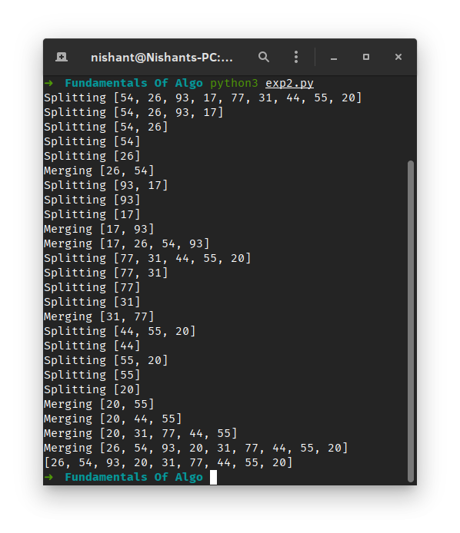

**CONCLUSION:** Thus, we have studied toWrite python program to sort n numbers using Merge sort algorithm.